DIS-US-Cul- Mississippian- Dagger

A Mississippian ceremonial dagger made of Camden chert. Believed to represent a bird talon, which may have been attached to a costume

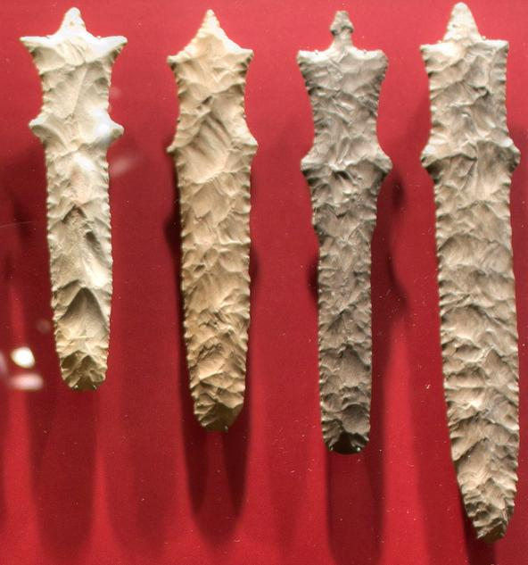

Mississippian symbolic weaponry types from the ‘Duck River cache” on display at the McClung

Museum. Mississippian swords located at the center; largest is 71

cm in length

.

### Mississippian Ceremonial Dagger, Camden Chert, Resembles Bird Talon, 6 inch.

### 

**These daggers were symbols believed to represent a bird talon, which may have been attached to a costume used in rituals and are not currently thought to have been used for common economic activities or in combat. Archaeologists visually identify the chert type used in the manufacture of the symbolic weapons as either Camden chert or Dover chert obtained from prehistoric quarry sites in north-central Tennessee**

Figure

3

-

Examples of common Mississippian symbolic weaponry

types from the ‘Duck River cache” on display at the McClung

Museum. Mississippian swords located at the center; largest is 71

cm in length

Studying stone resource selection among Mississippi Period cultures (A.D. 1000

–

1700) using the

FieldSpec 4

Ryan M. Parish, Ph.D. candidate, Department of Earth Sciences, University of Memphis, Memphis, TN.

The archaeological application of reflectance spectroscopy in sourcing

stone used by prehistoric people has great potential in reconstructing

human behavior. The FieldSpec

4

was used to analyze over 1,00

0

samples of chert (flint)

(Figure 1)

in order to create a spectral database

representative of 35 deposits located over the Midwestern and

Southeastern United States. Spectra previously collected upon

Mississippian symbolic we

aponry manufactured from chert

(Figure 2)

were compared within the spectral database. Matches were made

between the Mississippian artifacts of unknown source to sample groups.

The

results

allowed the researcher to construct hypotheses regarding trade

ne

tworks and

the importance of resource selection in the social meaning

of the symbolic weaponry.

Archaeologists typically rely on visually identification to identify the source of chert used

in the

manufacture of stone tools. Significant color variation exists within and between stone deposits making

visual identification

a problematic method

.

Analytical s

ource data allows archaeologists to examine a

number of different aspects of human behavior such

as migration, trade, technology

and resource

selection decisions.

Figure

1

-

FieldSpec 4 in a laboratory

configuration poised to analyze a

sample of chert

Figure

2

-

Typical spectrum of chert

Mississippian symbolic weaponry exists in the

form of large stone maces, hooks, claws, daggers

and swords

(Figure 3

)

. They were manufactured

by skilled individuals who expertly chipped

pieces of chert into incredibly complex thin items.

The Mississippian culture groups lived in the

southeastern United States about 1,000 years ago

up until contact with European colonis

ts in the

16

th

and 17

th

centuries. They were chiefdom level

societies, built large earthen mounds, and grew

corn, beans and squash.

The symbolic weaponry

is often found

in burials of elite members of

society.

Archaeologists interpret these items as

symbols used in rituals and are not currently

thought to have been used

for

common economic

activities or in

combat.

Archaeologists visually identify the chert type

used in the manufacture of the symbolic weapons as Dover chert

obtained

from prehistoric quarry sites in

north

-

central Tennessee

(Figure 4

)

. However, outc

rops of visually similar chert exist from the southern

tip of Illinois, through Kentucky, Tennessee, Alabama and Georgia. The Mississippian symbolic

weaponry is found

on archaeological sites

from Oklahoma to Georgia and the single source of the

material u

sed to manufacture these items has significant implications for understanding the economic and

political

decisions

during this time period. The

study non

-

destructively analyzed 30

Mississippian swords and statistically matched

their spectra within the che

rt spectral database.

The results show that the use of chert material

from a variety of locations possibly existed and

the sole use of chert from

the Dover quarry sites

does not appear to be valid. The use of VNIR

spectral data applied to sourcing studi

es was

shown to be an accurate, cost efficient and fast

method. VNIR reflectance spectroscopy is not

traditionally used to conduct this type of

research. The study demonstrates that the

portable FieldSpec 4 is well suited to

rapidly

an

alyze both large

numbers of samples

and

museum quality artifacts.